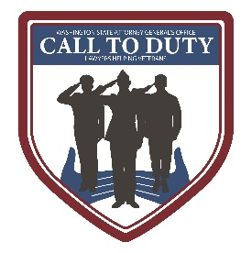

**OMVLA Volunteer Attorney**

Program Description

The Office of Military & Veteran Legal Assistance (OMVLA) facilitates civil legal assistance for Washington veterans, service members, and their families. OMVLA receives requests for legal assistance and refers qualified requests to volunteer attorneys who can offer assistance with civil legal issues.

General Volunteer Duties

* Provide a 30-60 minute consultation about the client’s civil legal issue
* As appropriate, summarize any advice or discussion in writing and provide to the client after the consultation
* Provide client with self-help materials or other referrals or resources to prepare them for *pro se* representation
* We also have opportunities for attorneys to volunteer at clinics throughout the year

Time Commitment

Volunteers are encouraged to assist at least one client per year, but have full discretion to decide how much assistance to provide in every case

Qualifications

* Licensed to practice law in Washington State
* Willingness to advise a client facing a legal issue in a familiar practice area

Benefits

* Contribute towards improving access to justice for Washington’s military and veteran community
* Access to free on-demand [Public Service Education CLE courses](https://www.mywsba.org/PersonifyEbusiness/Default.aspx?TabID=1503#filter=%7B%22Facet%22%3Anull,%22SubFacet%22%3Anull,%22Category%22%3A%7B%22Name%22%3A%22Public+Service+Education%22,%22Value%22%3A%22PUBLIC+SERVICE+EDUCATION%22%7D,%22SubCategory%22%3Anull%7D&searchTerm=&searchItemNameTerm=&searchDescriptionTerm=&productClass=) from WSBA
* Malpractice insurance for cases accepted through this program

Register to volunteer

[www.atg.wa.gov/volunteer-opportunities](http://www.atg.wa.gov/volunteer-opportunities)

Questions? Email [omvla@atg.wa.gov](mailto:omvla@atg.wa.gov)