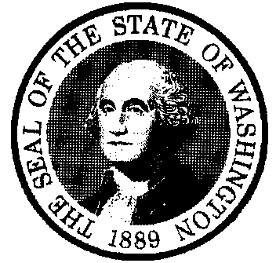
STATE OF WASHINGTON

DEPARTMENT OF SOCIAL AND HEALTH SERVICES
OFFICE OF FINANCIAL RECOVERY

P.O. Box 9501 Olympia, Washington 98507-9501

800-562-6114 Option 5

VENDOR

Estate Recovery Agents
Don Barton  Revenue Agent 3 (Lead) | 360-664-5460  360-999- | Don.Barton@dshs.wa.gov | Customer & Community Relations
Michael Johnston  Revenue Agent 2  BARCODE: A-CH | 360-664-5486 | Michael.Johnston@dshs.wa.gov | Estate Recovery Caseload:  B – E – T – W – X
Lisa Ellis  Revenue Agent 2  BARCODE: CI-GA | 360-664-5673 | Lisa.Ellis@dshs.wa.gov | Estate Recovery Caseload:  C – J – S
Vacant  Revenue Agent 2  BARCODE: GB-KA |  |  | Estate Recovery Caseload:
Chuck Preston  Revenue Agent 2  BARCODE: KB-M | 360-664-5451 | Chuck.Preston@dshs.wa.gov | Estate Recovery Caseload:  F – G – K – L – O – V
Rosyln Scott  Revenue Agent 2  BARCODE: N-SH | 360-664-5544 | Roslyn.Scott2@dshs.wa.gov | Estate Recovery Caseload:  A – D – M – P
Amanda Davidson  Revenue Agent 2  BARCODE: SI-Z | 360-664-5572 | Amanda.davidson2@dshs.wa.gov | Estate Recovery Caseload:  H – I – N – Q – R – U – Y – Z

A | Roslyn Scott
B | Michael Johnston
C | Lisa Ellis
D | Roslyn Scott
E | Michael Johnston
F | Charles Preston
G | Charles Preston
H | Amanda Davidson
I | Amanda Davidson
J | Lisa Ellis
K | Charles Preston
L | Charles Preston
M | Roslyn Scott
N | Amanda Davidson
O | Charles Preston
P | Roslyn Scott
Q | Amanda Davidson
R | Amanda Davidson
S | Lisa Ellis
T | Michael Johnston
U | Amanda Davidson
V | Charles Preston
W | Michael Johnston
X | Michael Johnston
Y | Amanda Davidson
Z | Amanda Davidson

Supervisor | Payoff Requests  (Title Companies only) | Team email
Denise Rainville | OFRERUPayoffs@dshs.wa.gov | OFRERU@dshs.wa.gov
denise.rainville3@dshs.wa.gov
Cell: 360-791-2682

