The New York Times
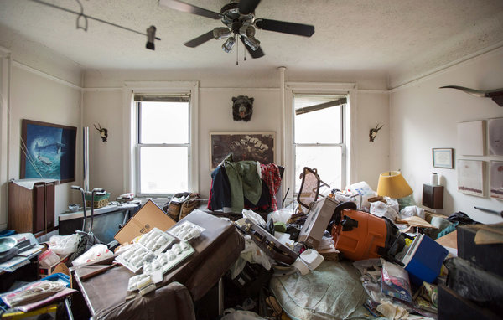
Sniffing a fetid odor, George Bell's neighbor called 911. Credit Josh Haner/The New York Times

The Lonely Death of George Bell
Each year around 50,000 people die in New York, some alone and unseen. Yet death even in such forlorn form can cause a surprising amount of activity. Sometimes, along the way, a life’s secrets are revealed.
Written by N. R. KLEINFIELD; Photographs by JOSH HANER
OCT. 17, 2015
They found him in the living room, crumpled up on the mottled carpet. The police did. Sniffing a fetid odor, a neighbor had called 911. The apartment was in north-central Queens, in an unassertive building on 79th Street in Jackson Heights.
The apartment belonged to a George Bell. He lived alone. Thus the presumption was that the corpse also belonged to George Bell. It was a plausible supposition, but it remained just that, for the puffy body on the floor was decomposed and unrecognizable. Clearly the man had not died on July 12, the Saturday last year when he was discovered, nor the day before nor the day before that. He had lain there for a while, nothing to announce his departure to the world, while the hyperkinetic city around him hurried on with its business.
Neighbors had last seen him six days earlier, a Sunday. On Thursday, there was a break in his routine. The car he always kept out front and moved from one side of the street to the other to obey parking rules sat on the wrong side. A ticket was wedged beneath the wiper. The woman next door called Mr. Bell. His phone rang and rang.
Then the smell of death and the police and the sobering reason that George Bell did not move his car.
Each year around 50,000 people die in New York, and each year the mortality rate seems to graze a new low, with people living healthier and longer. A great majority of the deceased have relatives and friends who soon learn of their passing and tearfully assemble at their funeral. A reverent death notice appears. Sympathy cards accumulate. When the celebrated die or there is some heart-rending killing of the innocent, the entire city might weep.
A much tinier number die alone in unwatched struggles. No one collects their bodies. No one mourns the conclusion of a life. They are just a name added to the death tables. In the year 2014, George Bell, age 72, was among those names.
George Bell — a simple name, two syllables, the minimum. There were no obvious answers as to who he was or what shape his life had taken. What worries weighed on him. Whom he loved and who loved him.
Like most New Yorkers, he lived in the corners, under the pale light of obscurity.
Yet death even in such forlorn form can cause a surprising amount of activity, setting off an elaborate, lurching process that involves a hodgepodge of interlocking characters whose livelihoods flow in part or in whole from death.
With George Bell, the ripples from the process would spill improbably and seemingly by happenstance from the shadows of Queens to upstate New York and Virginia and Florida. Dozens of people who never knew him, all cogs in the city’s complicated machinery of mortality, would find themselves settling the affairs of an ordinary man who left this world without anyone in particular noticing.
In discovering a death, you find a life story and perhaps meaning. Could anything in the map of George Bell’s existence have explained his lonely end? Possibly not. But it was true that George Bell died carrying some secrets. Secrets about how he lived and secrets about who mattered most to him. Those secrets would bring sorrow. At the same time, they would deliver rewards. Death does that. It closes doors but also opens them.
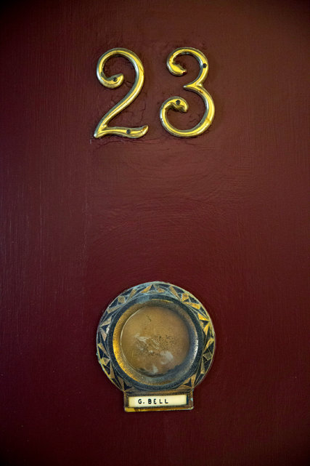
The apartment belonged to a George Bell. He lived alone. Credit Josh Haner/The New York Times
ONCE FIREFIGHTERS had jimmied the door that July afternoon, the police squeezed into a beaten apartment groaning with possessions, a grotesque parody of the “lived-in” condition. Clearly, its occupant had been a hoarder.
The officers from the 115th Precinct called the medical examiner’s office, which involves itself in suspicious deaths and unidentified bodies, and a medical legal investigator arrived. His task was to rule out foul play and look for evidence that could help locate the next of kin and identify the body. In short order, it was clear that nothing criminal had taken place (no sign of forced entry, bullet wounds, congealed blood).
A Fire Department paramedic made the obvious pronouncement that the man was dead; even a skeleton must be formally declared no longer living. The body was zipped into a human remains pouch. A transport team from the medical examiner’s office drove it to the morgue at Queens Hospital Center, where it was deposited in one of some 100 refrigerated drawers, cooled to 35 degrees.
It falls to the police to notify next of kin, but the neighbors did not know of any. Detectives grabbed some names and phone numbers from the apartment, called them and got nothing: The man had no wife, no siblings. The police estimate that they reach kin 85 percent of the time. They struck out with George Bell.
At the Queens morgue, identification personnel got started. Something like 90 percent of the corpses arriving at city morgues are identified by relatives or friends after they are shown photographs of the body. Most remains depart for burial within a few days. For the rest, it gets complicated.
The easiest resolution is furnished by fingerprints; otherwise by dental and medical records or, as a last resort, by DNA. The medical examiner can also do a so-called contextual ID; when all elements are considered, none of which by themselves bring certainty, a sort of circumstantial identification can be made.
Fingerprints were taken, which required days because of the poor condition of the fingers. Enhanced techniques had to be used, such as soaking the fingers in a solution to soften them. The prints were sent to city, state and federal databases. No hits.
ONCE NINE DAYS had elapsed and no next of kin had come forth, the medical examiner reported the death to the office of the Queens County public administrator, an obscure agency that operates out of the State Supreme Court building in the Jamaica neighborhood. Its austere quarters are adjacent to Surrogate’s Court, familiarly known as widows and orphans court, where wills are probated and battles are often waged over the dead.
Each county in New York City has a public administrator to manage estates when there is no one else to do so, most commonly when there is no will or no known heirs.
Public administrators tend to rouse attention only when complaints flare over their competence or their fees or their tendency to oversee dens of political patronage. Or when they run afoul of the law. Last year, a former longtime counsel to the Bronx County public administrator pleaded guilty to grand larceny, while a bookkeeper for the Kings County public administrator was sentenced to a prison term for stealing from the dead.
Recent audits by the city’s comptroller found disturbing dysfunction at both of those offices, which the occupants said had been overstated. The most recent audit of the Queens office, in 2012, raised no significant issues.
The Queens unit employs 15 people and processes something like 1,500 deaths a year. Appointed by the Queens surrogate, Lois M. Rosenblatt, a lawyer, has been head of the office for the past 13 years. Most cases arrive from nursing homes, others from the medical examiner, legal guardians, the police, undertakers. While a majority of estates contain assets of less than $500, one had been worth $16 million. Meager estates can move swiftly. Bigger ones routinely extend from 12 to 24 months.
The office extracts a commission that starts at 5 percent of the first $100,000 of an estate and then slides downward, money that is entered into the city’s general fund. An additional 1 percent goes toward the office’s expenses. The office’s counsel, who for 23 years has been Gerard Sweeney, a private lawyer who mainly does the public administrator’s legal work, customarily gets a sliding legal fee that begins at 6 percent of the estate’s first $750,000.
“You can die in such anonymity in New York,” he likes to say. “We’ve had instances of people dead for months. No one finds them, no one misses them.”
The man presumed to be George Bell joined the wash of cases, a fresh arrival that Ms. Rosenblatt viewed as nothing special at all.
Meanwhile, the medical examiner needed records — X-rays would do — to confirm the identity of the body. The office took its own chest X-rays but still required earlier ones for comparison.
The medical examiner’s office had no idea which doctors the man had seen, so in a Hail Mary maneuver, personnel began cold-calling hospitals and doctors in the vicinity, in a pattern that radiated outward from the Jackson Heights apartment. Whoever picked up was asked if by chance a George Bell had ever dropped in.
THREE INVESTIGATORS work for the Queens County public administrator. They comb through the residences of the departed, mining their homes for clues as to what was owned, who their relatives were. It’s a peculiar kind of work, seeing what strangers had kept in their closets, what they hung on the walls, what deodorant they liked.
On July 24, two investigators, Juan Plaza and Ronald Rodriguez, entered the glutted premises of the Bell apartment, clad in billowy hazmat suits and bootees. Investigators work in pairs, to discourage theft.
Bleak as the place was, they had seen worse. An apartment so swollen with belongings that the tenant, a woman, died standing up, unable to collapse to the floor. Or the place they fled swatting at swarms of fleas.
Yes, they saw a human existence that few others did.
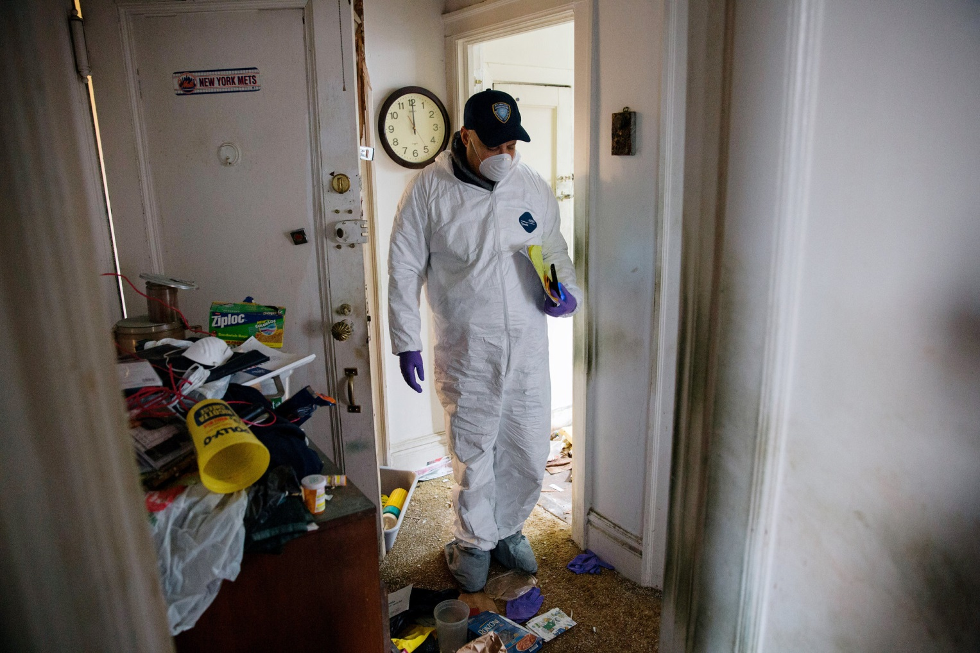
Ronald Rodriguez is one of three investigators for the Queens County public administrator's office. He combs through the residences of the departed, documenting what they owned and seeking clues to who their relatives were. Credit Josh Haner/The New York Times
Mr. Plaza had been a data entry clerk before joining his macabre field in 1994; Mr. Rodriguez had been a waiter and found his interest piqued in 2002.
What qualified someone for the job? Ms. Rosenblatt, the head of the office, summed it up: “People willing to go into these disgusting apartments.”
The two men foraged through the unedited anarchy, 800 square feet, one bedroom. A stench thickened the air. Mr. Plaza dabbed his nostrils with a Vicks vapor stick. Mr. Rodriguez toughed it out. Vicks bothered his nose.
The only bed was the lumpy foldout couch in the living room. The bedroom and bathroom looked pillaged. The kitchen was splashed with trash and balled-up, decades-old lottery tickets that had failed to deliver. A soiled shopping list read: sea salt, garlic, carrots, broccoli (two packs), “TV Guide.”
The faucet didn’t work. The chipped stove had no knobs and could not have been used to cook in a long time.
The men scavenged for a will, a cemetery deed, financial documents, an address book, computer, cellphone, those sorts of things. Photographs might show relatives — could that be a mom or sis beaming in that picture on the mantel?
Portable objects of value were to be retrieved. A Vermeer hangs on the wall? Grab it. Once they found $30,000 in cash, another time a Rolex wedged inside a radio. But the bar is not placed nearly that high: In one instance, they lugged back a picture of the deceased in a Knights of Malta outfit.
In the slanting light they scooped up papers from a table and some drawers in the living room. They found $241 in bills and $187.45 in coins. A silver Relic watch did not look special, but they took it in case.
Fastened to the walls were a bear’s head, steer horns and some military pictures of planes and warships. Over the couch hung a photo sequence of a parachutist coming in for a landing, with a certificate recording George Bell’s first jump in 1963. Chinese food cartons and pizza boxes were ubiquitous. Shelves were stacked with music tapes and videos: “Top Gun,” “Braveheart,” “Yule Log.”
A splotched calendar from Lucky Market hung in the bathroom, flipped open to August 2007.
Hoarding is deemed a mental disorder, poorly understood, that stirs people to incoherent acts; sufferers may buy products simply to have them. Amid the mess were a half-dozen unopened ironing board covers, multiple packages of unused Christmas lights, four new tire-pressure gauges.
The investigators returned twice more, rounding up more papers, another $95. They found no cellphone, no computer or credit cards.
Rummaging through the personal effects of the dead, sensing the misery in these rooms, can color your thoughts. The work changes people, and it has changed these men.
Mr. Rodriguez, 57 and divorced, has a greater sense of urgency. “I try to build a life like it’s the last day,” he said. “You never know when you will die. Before this, I went along like I would live forever.”

Juan Plaza, another investigator, says the solitude of so many deaths wears on him. Credit Josh Haner/The New York Times Photo
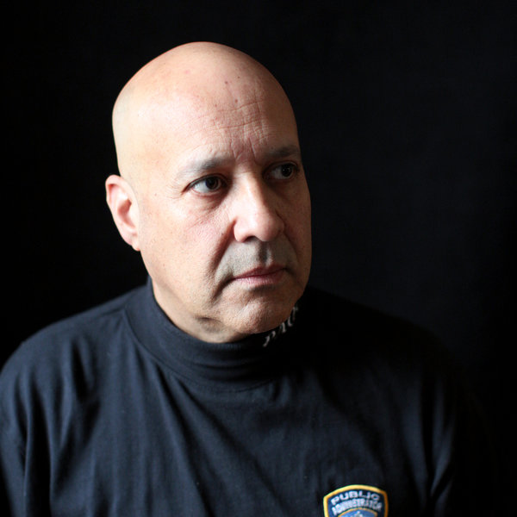
“I try to build a life like it’s the last day,” Mr. Rodriguez said. Credit Josh Haner/The New York Times
The solitude of so many deaths wears on Mr. Plaza, the fear that someday it will be him splayed on the floor in one of these silent apartments. “This job teaches you a lot,” he said. “You learn whatever material stuff you have you should use it and share it. Share yourself. People die with nobody to talk to. They die and relatives come out of the woodwork. ‘He was my uncle. He was my cousin. Give me what he had.’ Gimme, gimme. Yet when he was alive they never visited, never knew the person. From working in this office, my life changed.”
He is 52, also divorced, and without children, but he keeps expanding his base of friends. Every day, he sends them motivational Instagram messages: “With each sunrise, may we value every minute”; “Be kind, smile to the world and it will smile back”; “Share your life with loved ones”; “Love, forgive, forget.”
He said: “When I die, someone will find out the same day or the next day. Since I’ve worked here, my list of friends has gotten longer and longer. I don’t want to die alone.”
IN HIS QUEENS CUBICLE, wearing rubber gloves, Patrick Stressler thumbed through the sheaf of documents retrieved by the two investigators. Mr. Stressler, the caseworker with the public administrator’s office responsible for piecing together George Bell’s estate, is formally a “decedent property agent,” a title he finds useful as a conversation starter at parties. He is 27, and had been a restaurant cashier five years ago when he learned you could be a decedent property agent and became one.
He began with the pictures. Mr. Stressler mingles in the leavings of people he can never meet and especially likes to ponder the photographs so “you get a sense of a person’s history, not that they just died.”
The snapshots ranged over the humdrum of life. A child wearing a holster and toy pistols. A man in military dress. Men fishing. A young woman sitting on a chair in a corner. A high school class on a stage, everyone wearing blackface. “Different times,” Mr. Stressler mused.
In the end, the photos divulged little of what George Bell had done across his 72 years.
The thicket of papers yielded a few hazy kernels. An unused passport, issued in 2007 to George Main Bell Jr., showing a thick-necked man with a meaty face ripened by time, born Jan. 15, 1942. Documents establishing that his father — George Bell — died in 1969 at 59, his mother, Davina Bell, in 1981 at 76.
Some holiday cards. Several from an Elsie Logan in Red Bank, N.J., thanking him for gifts of Godiva chocolates. One, dated 2001, said: “I called Sunday around 2 — no answer. Will try again.” A 2007 Thanksgiving Day card read, “I have been trying to call you — but no answer.”
A 2001 Christmas card signed, “Love always, Eleanore (Puffy),” with the message: “I seldom mention it, but I hope you realize how much it means to have you for a friend. I care a lot for you.”
The kitchen was splashed with trash and balled-up lottery tickets, decades old, that failed to deliver. The faucet did not work. The chipped stove had no knobs and could not have been used to cook in a long time. Credit Josh Haner/The New York Times Photo
Shelves were stacked with music tapes and videos. Credit Josh Haner/The New York Times
Amid the mess were a half-dozen unopened ironing board covers, multiple packages of unused Christmas lights, four new tire-pressure gauges. Credit Josh Haner/The New York Times
Cards from a Thomas Higginbotham, addressed to “Big George” and signed “friend, Tom.”
A golden find: H&R Block-prepared tax returns, useful for divining assets. The latest showed adjusted gross income of $13,207 from a pension and interest, another $21,311 from Social Security. The bank statements contained the biggest revelation: For what appeared to be a simple life, they showed balances of several hundred thousand dollars. Letters went out to confirm the amounts.
No evidence of stocks or bonds, but a small life insurance policy, with the beneficiaries his parents. And there was a will, dated 1982. It split his estate evenly among three men and a woman of unknown relation. And specified that George Bell be cremated.
Using addresses he found online, Mr. Stressler sent out form letters asking the four to contact him. He heard only from a Martin Westbrook, who called from Sprakers, a hamlet in upstate New York, and said he had not spoken with George Bell in some time. The will named him as executor, but he deferred to the public administrator.
Loose ends began to be tidied up. The car, a silver 2005 Toyota RAV4, was sent to an auctioneer. There was a notice advising that George Bell had not responded to two juror questionnaires and was now subpoenaed to appear before the commissioner of jurors; a letter went out saying he would not be there. He was dead.
If an apartment’s contents have any value, auction companies bid for them. When they don’t, “cleanout companies” dispose of the belongings. George Bell’s place was deemed a cleanout.
Among his papers was an honorable military discharge from 1966, following six years in the United States Army Reserve. A request was made to the Department of Veterans Affairs, national cemetery administration, in St. Louis, for burial in one of its national cemeteries, with the government paying the bill.
St. Louis responded that George Bell did not qualify as a veteran, not having seen active duty or having died while in the Reserves. The public administrator appealed the rebuff. A week later, 16 pages came back from the centralized satellite processing and appeals unit that could be summed up in unambiguous concision: No.
Another thing the public administrator takes care of is having the post office forward the mail of the deceased. Statements may arrive from brokerage houses. Letters could pinpoint the whereabouts of relatives. When magazines show up, the subscriptions are ended and refunds requested. Could be $6.82 or $12.05, but the puny sums enter the estate, pushing it incrementally upward.
Not much came for George Bell: bank statements, a notice on the apartment insurance, utility bills, junk mail.
EVERY LIFE DESERVES to come to a final resting place, but they’re not all pretty. Most estates arrive with the public administrator after the body has already been buried by relatives or friends or in accordance with a prepaid plan.
When someone dies destitute and forsaken, and one of various free burial organizations does not learn of the case, the body ends up joining others in communal oblivion at the potter’s field on Hart Island in the Bronx, the graveyard of last resort.
If there are funds, the public administrator honors the wishes of the will or of relatives. When no one speaks for the deceased, the office is partial to two fairly dismal, cut-rate cemeteries in New Jersey. It prefers the total expense to come in under $5,000, not always easy in a city where funeral and burial costs can be multiples of that.
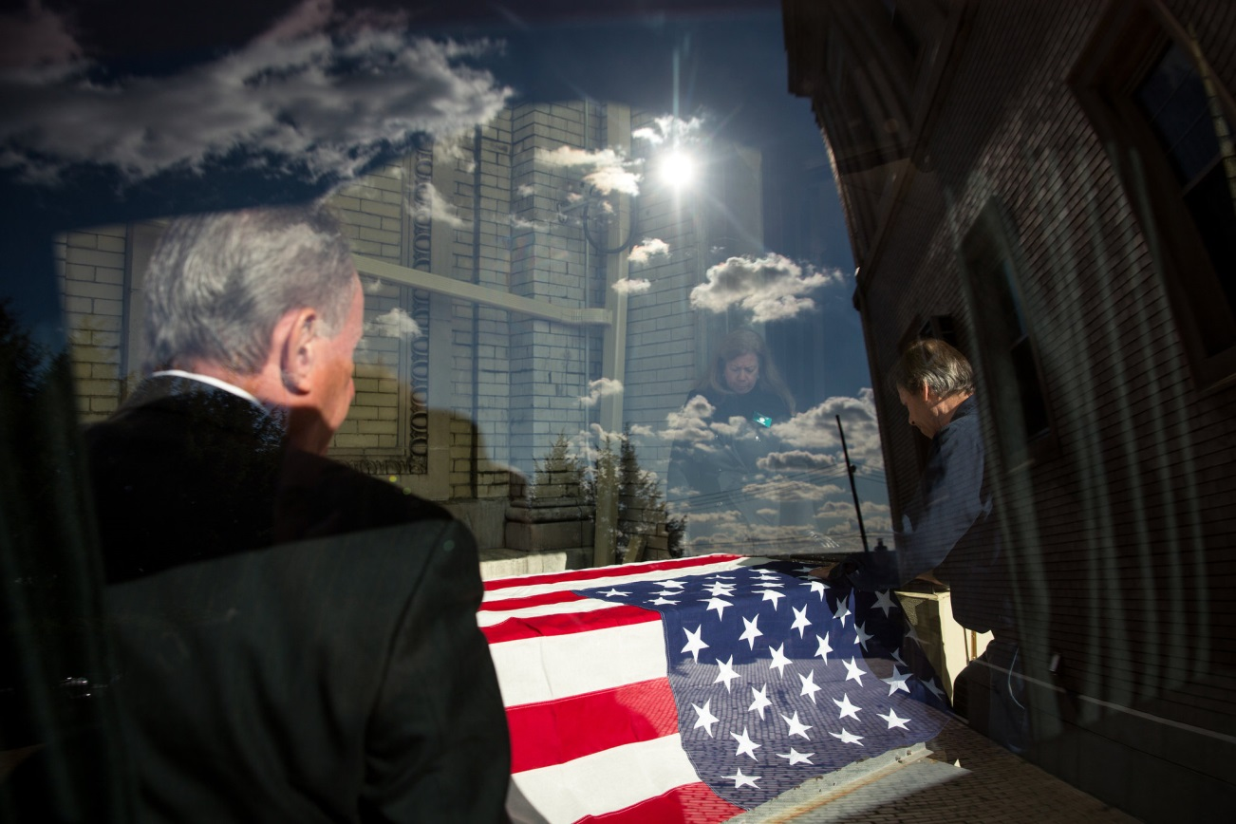
On Nov. 15, John Sommese of the Simonson Funeral Home settled into a rented hearse, eased into the sparse traffic and drove George Bell's body to a crematorium. Credit Josh Haner/The New York Times
Simonson Funeral Home in Forest Hills was picked by Susan Brown, the deputy public administrator, to handle George Bell once his identity was verified. It is among 16 regulars that she rotates the office’s deaths through.
George Bell’s body was hardly the first to be trapped in limbo. Some years ago, one had lingered for weeks while siblings skirmished over the funeral specifics. The decedent’s sister wanted a barbershop quartet and brass band to perform; a brother preferred something solemn. Surrogate’s Court nodded in favor of the sister, and the man got a melodious send-off.
The medical examiner was not having any luck with George Bell. The cold calls to doctors and hospitals continued, but as the inquiries bounced around Queens, the discouraging answers came back slowly and redundantly: no George Bell.
In the interim, the medical examiner filed an unverified death certificate, on July 28. The cause of death was determined to be hypertensive and arteriosclerotic cardiovascular disease, with obesity a significant factor. This was surmised, based on the position in which the body was found, its age, the man’s size and the statistical likelihood of it being the cause. Occupation was listed as unknown.
City law specifies that bodies be buried, cremated or sent from the city within four days of discovery, unless an exemption is granted. The medical examiner can release even an unverified body for burial. Absent a corpse’s being confirmed, however, the policy of the medical examiner is not to allow cremation. What if there has been a mistake? You can’t un-cremate someone.
So days scrolled past. Other corpses streamed through the morgue, pausing on their way to the grave, while the body presumed to be George Bell entered its second month of chilled residence. Then its third.
IN EARLY SEPTEMBER last year, a downstairs neighbor complained to the public administrator that George Bell’s refrigerator was leaking through the ceiling and that vermin might be scuttling about.
Grandma’s Attic Cleanouts was sent over to remove the offending appliance. Diego Benitez, the company’s owner, showed up with two workers.
The refrigerator was unplugged, with unfrozen frozen vegetables and Chinese takeout rotting inside. Roaches had moved in. Mr. Benitez doused it with bug spray. He plugged it in to chill the food and rid it of the smell, then cleaned it out and took it to a recycling center in Jamaica. A few weeks later, Wipeout Exterminating came in and treated the whole place.
Meanwhile, the medical examiner kept calling around hunting for old X-rays. In late September, the 11th call hit pay dirt. A radiology provider had chest X-rays of George Bell dating from 2004. They were in a warehouse, though, and would take some time to retrieve.
Weeks tumbled by. In late October, the radiology service reported: Sorry, the X-rays had been destroyed. The medical examiner asked for written confirmation. Back came the response: Never mind, the X-rays were there. In early November, they landed at the medical examiner’s office.
The X-rays were compared, and bingo. In the first week of November, nearly four months after it had arrived, the presumed corpse of George Bell officially became George Bell, deceased, of Jackson Heights, Queens.
COLD OUT. Streaks of sunshine splashing over Queens. On Saturday morning, Nov. 15, John Sommese settled into a rented hearse, eased into the sparse traffic and drove to the morgue. He owns Simonson Funeral Home. At age 73, he remained a working owner in a city of dwindling deaths.
At the morgue, an attendant withdrew the body from the drawer, and both medical examiner and undertaker checked the identity tag. Using a hydraulic lift, the attendant swung the body into the wooden coffin. George Bell was at last going to his eternal home.
The coffin was wheeled out and guided into the back of the hearse. Mr. Sommese smoothed an American flag over it. The armed forces had passed on a military burial, but George Bell’s years in the Army Reserves were good enough for the funeral director, and he abided by military custom.
Next stop was U.S. Columbarium at Fresh Pond Crematory in Middle Village, for the cremation. Mr. Sommese made good time along the loud streets lined with shedding trees. The volume on the radio was muted; the dashboard said Queen’s “You’re My Best Friend” was playing.
While the undertaker said he didn’t dwell much on the strangers he transported, he allowed how instances like this saddened him — a person dies and nobody shows up, no service, no one from the clergy to say a few kind words, to say rest in peace.
The undertaker was a Christian, and believed that George Bell was already in another place, a better place, but still. “I don’t think everyone should have an elaborate funeral,” he said in a soft voice. “But I think burial or cremation should be with respect, or else what is society about? I think about this man. I believe we’re all connected. We’re all products of the same God. Does it matter that this man should be cremated with respect? Yes, it does.”

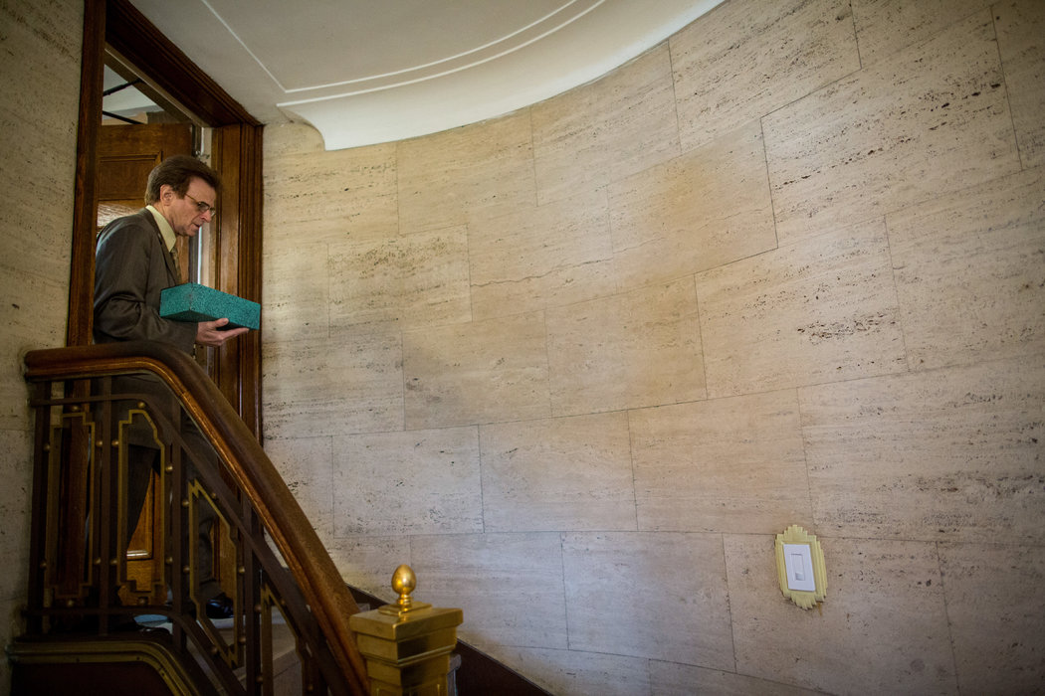
Several days after George Bell's cremation, the superintendent at U.S. Columbarium took an urn shaped like a small shoe box down to the storage area. Credit Josh Haner/The New York Times
He consulted the mirror and blended into the next lane. “You can have a fancy funeral, but people don’t pay for kindness,” he went on. “They don’t pay for understanding. They don’t pay for caring. This man is getting caring. I care about this man.”
At U.S. Columbarium, he steered around to the rear, to the unloading dock. Another hearse stood there. Yes — a line at the crematory.
Squinting in the sun, Mr. Sommese paced in the motionless air. After 15 minutes, the dock opened up and the undertaker angled the hearse in. Workers took the coffin. Mr. Sommese kept the flag. Normally, it would go to the next of kin. There being none, the undertaker folded it up to use again.
The cremation process, what U.S. Columbarium calls the “journey,” consumed nearly three hours. Typically, cremains are ready for pickup in a couple of days. For an extra $180, the columbarium provides same-day express service, which was unneeded in this case.
Some 40,000 cremains were stored at the columbarium, almost all of them tucked into handsome individual wall niches, viewable through glass. Downstairs was a storage area near the bathrooms with a bronze tree affixed to the door. This was the Community Tree. Behind the door cremains were stacked up and stored out of sight. The budget alternative. Names were etched on the tree leaves. Some time ago, when the leaves filled up, doves were added.
Several days after the cremation, the superintendent stacked an urn shaped like a small shoe box inside the storage area. Then he nailed a metal dove, wings spread, above the right edge of the tree. It identified the new addition: “George M. Bell Jr. 1942-2014.”
ON ALTERNATE TUESDAYS, David R. Maltz & Company, in Central Islip, N.Y., auctions off 100 to 150 cars; other days, it auctions real estate, jewelry and pretty much everything else. It has sold the Woodcrest Country Club in Muttontown, N.Y., four engines from an automobile shredder, 22 KFC franchises. Items arrive from bankruptcies, repossessions and estates, including a regular stream from the Queens public administrator.
In the frosty gloom of Dec. 30, as a hissing wind spun litter through the air, the Maltz company had among its cars a 2011 Mustang convertible, multiple Mercedes-Benzes, two cars that didn’t even run and George Bell’s 2005 Toyota. Despite its age, it had just over 3,000 miles on it, brightening its appeal.
In a one-minute bidding spasm — “3,000 the bid, 3,500, 35 the bid, 4,000…” — the car went for $9,500, beating expectations. After expenses, $8,631.50 was added to the estate. The buyer was Sam Maloof, a regular, who runs a used car dealership, Beltway Motor Sales, in Brooklyn and planned to resell it. After he brought it back, his sister and secretary, Janet Maloof, adored it. She had the same 2005 model, same color, burdened with over 100,000 miles. So, feeling the holiday spirit, he gave her George Bell’s car.
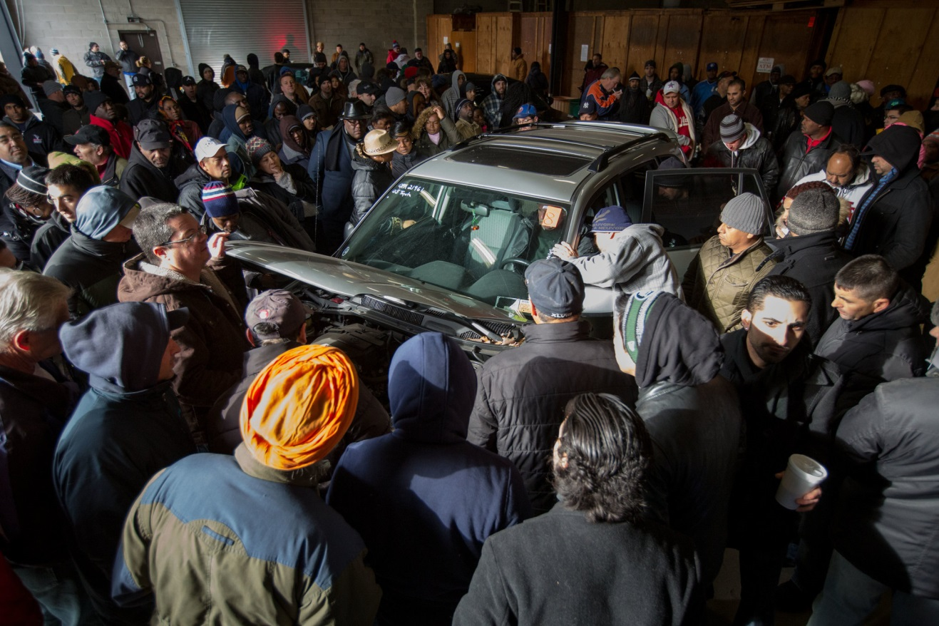
On Dec. 30, David R. Maltz & Company, in Central Islip, N.Y., auctioned off George Bell’s 2005 Toyota. Despite its age, the vehicle had just over 3,000 miles on it, brightening its appeal. Credit Josh Haner/The New York Times
In a couple of weeks, the only other valuable possession extracted from the apartment, the Relic watch, came up for sale at a Maltz auction of jewelry, wine, art and collectibles. The auction was dominated by 42 estates put up by the Queens public administrator, the thinnest by far being George Bell’s. Bidding on the watch began at $1 and finished at $3. The winner was a creaky, unemployed man named Tony Nik. He was in a sulky mood, mumbling after his triumph that he liked the slim price.
Again after expenses, another $2.31 trickled into the Bell estate.
On a sun-kindled day a week later, six muscled men from GreenEx, a junk removal business, arrived to empty the cluttered Queens apartment. Dispassionately, they scooped up the dusty traces of George Bell’s life and shoveled them into trash cans and bags. They broke apart the furniture with hammers. Tinny music poured from a portable radio.
Eyeing the bottomless thickets, puzzling over what heartbreak they told of, one of the men said: “Depression, I think. People get depressed and then, Lord help them, forget about it.”
Seven hours they went at it, flinging everything into trucks destined for a Bronx dump where the rates were good.
Some nuggets they salvaged for themselves. One man fancied a set of Marilyn Monroe porcelain plates. Another worker plucked up an unopened jumbo package of Nike socks, some model cars and some brand-new sponges. Yet another claimed the television and an unused carbon monoxide detector. Gatherings from a life, all worth more than that $3 watch.
A spindly worker with taut arms crouched down to inspect some never-worn tan work boots, still snug in their box. They were a size big, but he slid them on and liked the fit.
He cleaned George Bell’s apartment wearing the dead man’s boots.
THE PEOPLE NAMED to split the assets in the will were known as the legatees. Over 30 years had passed since George Bell chose them: Martin Westbrook, Frank Murzi, Albert Schober and Eleanore Albert. Plus, there was a beneficiary on two bank accounts: Thomas Higginbotham.
Elizabeth Rooney, a kinship investigator in the office of Gerard Sweeney, the public administrator’s counsel, set out to help find them. By law, she also had to hunt for the next of kin, down to a first cousin once removed, the furthest relative eligible to lay claim to an estate. They had to be notified, should they choose to contest the will.
There was time, for George Bell’s assets could not be distributed until seven months after the public administrator had been appointed, the period state law specifies for creditors to step forward.
Prowling the Internet, Ms. Rooney learned that Mr. Murzi and Mr. Schober were dead. Mr. Westbrook was in Sprakers and Mr. Higginbotham in Lynchburg, Va. Ms. Rooney found Ms. Albert, now going by the name Flemm, upstate in Worcester.
They were surprised to learn that George Bell had left them money. Ms. Flemm had spoken to him by phone a few weeks before he died; the others had not been in touch for years.
A core piece of Ms. Rooney’s job was drafting a family tree going back three generations. Using the genealogy company Ancestry.com, she compiled evidence with things like census records and ship manifests, showing Bell relatives arriving from Scotland. Her office once produced a family tree that was six feet long. Another time it traced a family back to Daniel Boone.
Ms. Rooney created paternal and maternal trees, each with dozens of names. She found five living relatives: two first cousins on his mother’s side, one living in Edina, Minn., and the other in Henderson, Nev. Neither had been in contact with George Bell in decades, and didn’t know what he did for a living.
On the paternal side, Ms. Rooney identified two first cousins, one in Scotland and another in England, as well as a third whose whereabouts proved elusive.
When that cousin, Janet Bell, was not found, protocol dictated that a notice be published in a newspaper for four weeks, a gesture intended to alert unlocated relatives. With sizable estates, the court chooses The New York Law Journal, where the bill for the notice can run about $4,000. In this instance the court picked The Wave, a Queens weekly with a print circulation of 12,000, at a cost of $247.
The cousin might have been in Tajikistan or in Hog Jaw, Ark., or even on Staten Island, and the odds of her spotting the notice were approximately zero. Among thousands of such ads that Mr. Sweeney has placed, he is still awaiting his first response.
Word came that Eleanore Flemm had died of a heart attack, on Feb. 3 at 66. Since she had outlived Mr. Bell, her estate would receive her proceeds. Her heirs were her brother, James Albert, a private detective on Long Island who barely remembered the Bell name, along with a nephew and two nieces in Florida. One did not know George Bell had existed.
Death, though, isn’t social. It’s business. No need to have known someone to get his money.
On Feb. 20, a Queens real estate broker listed the Bell apartment at $219,000. It was the final asset to liquidate. Three potential buyers toured it the next day, and one woman’s offer of $225,000 was accepted.
Three months later, the building’s board said no. A middle-aged couple who lived down the block entered the picture, and, at $215,000, was approved. Their plan was to fix up the marred apartment, turn their own place over to their grown-up son and then move in, overwriting George Bell’s life.
Meanwhile, Mr. Sweeney appeared in Surrogate’s Court to request probate of the will. Besides the two known beneficiaries, he listed the possibility of unknown relatives and the unfound cousin. The court appointed a so-called guardian ad litem to review the will on behalf of these people, who might, in fact, be phantoms.
In September, Mr. Sweeney submitted a final accounting, the hard math of the estate, for court approval. No objections arrived. Tallied up, George Bell’s assets amounted to roughly $540,000. Bank accounts holding $215,000 listed Mr. Higginbotham as the sole beneficiary, and he got that directly. Proceeds from the apartment, other accounts, a life insurance policy, the car and the watch went to the estate: around $324,000.
A commission of $13,726 went to the city, a $3,238 fee to the public administrator, $19,453 to Mr. Sweeney.
Other expenses included things like the apartment maintenance, at $7,360; a funeral bill of $4,873; $2,800 for the cleanout company; $1,663 for the kinship investigator; a $222 parking ticket; a $704 Fire Department bill for ambulance service; $750 for the guardian ad litem; and $12.50 for an appraisal of the watch that sold for $3.
That left about $264,000 to be split between Mr. Westbrook and the heirs of Ms. Flemm. Some 14 months after a man died, his estate was settled and the proceeds were good to go.
For the recipients, George Bell had stepped out of eternity and united them by bestowing his money. No one in the drawn-out process knew why he had chosen them, nor did they need to. They only needed to know him in the quietude of death, as a man whose heart had stopped beating in Queens. But he had been like anyone, a human being who had built a life on this earth.
HIS LIFE BEGAN small and plain. George Bell was especially attached to his parents. He slept on the pullout sofa in the living room, while his parents claimed the bedroom, and he continued to sleep there even after they died. Both parents came from Scotland. His father was a tool-and-die machinist, and his mother worked for a time as a seamstress in the toy industry.
After high school, he joined his father as an apprentice. In 1961, he made an acquaintance at a local bar, a moving man. They became friends, and the moving man pulled George Bell into the moving business. His name was Tom Higginbotham. Three fellow movers also became friends: Frank Murzi, Albert Schober and Martin Westbrook. The men in the will. They mainly moved business offices, and they all guzzled booze, in titanic proportions.
Photo
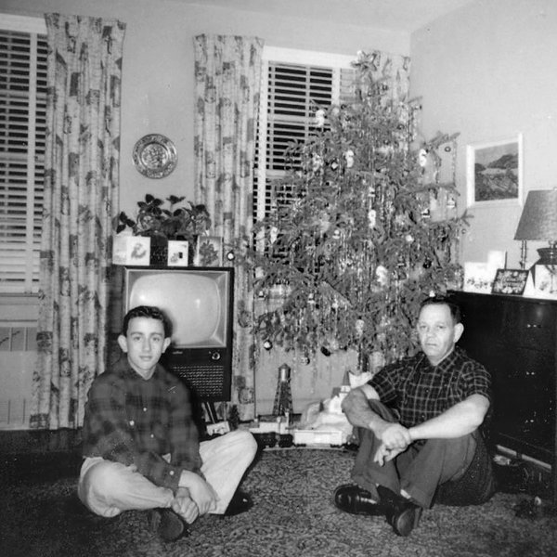
George Bell, left, in 1956. He was especially attached to his parents.
“We were a bunch of drunks,” Mr. Westbrook said. “I’m a juicer. But George put me to shame. He was a real nice guy, kind of a hermit. Boy, we had some good times.”
In the words of Mr. Higginbotham: “We were great friends. I don’t know if you can say it this way, but we were men who loved each other.”
They called him Big George, for he was a thickset, brawny man, weighing perhaps 210 pounds. Later, his ravenous appetite had him pushing 350.
He had a puckish streak. Once a woman invited him and Mr. Higginbotham to a party at her parents’ house. Her father kept tropical fish. She showed George Bell the tank. When he admired a distinctive fish, she said, “Oh, that’s an expensive one.” He picked up a net, caught the fish and swallowed it.
One day the friends were moving a financial firm. After they had fitted the desks into the new offices, George Bell slid notes into the drawers, writing things like: “I’m madly in love with you. Meet me at the water cooler.” Or: “There’s a bomb under your chair. Your next move might be your last.”
Dumb pranks. Big George being Big George.
Friends, though, found him difficult to crack open. There were things inside no one could get out. You learned to suppress your questions around him.
He had his burdens. His father died young. As she aged, his mother became crippled by arthritis. He cared for her, fetching her food and bathing her until her death.
He was fastidious about his money, only trusted banks for his savings. There was a woman he began dating when she was 19 and he was 25. “We got real keen on each other,” she said later. “He made me feel special.”
A marriage was planned. They spoke to a wedding hall. He bought a suit. Then, he told friends, the woman’s mother had wanted him to sign a prenuptial agreement to protect her daughter if the marriage should break apart. He ended the engagement, and never had another serious relationship.
That woman was Eleanore Albert, the fourth name in the will.
Some years later, she married an older man who made equipment for a party supply company, and moved upstate to become Ms. Flemm. In 2002, her husband died.
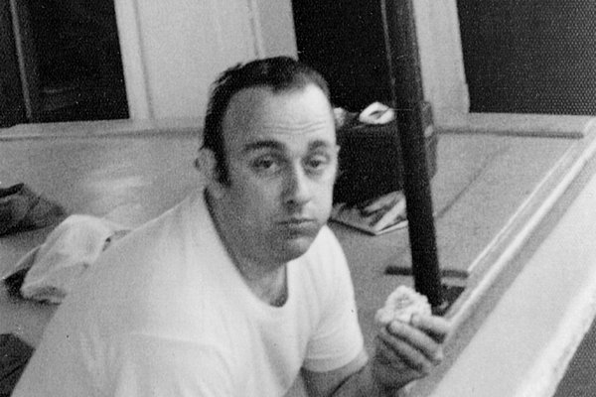
They called him Big George, for he was a thickset, brawny man, weighing perhaps 210 pounds. Later, his ravenous appetite had him pushing 350.
Distance and time never dampened the emotional affinity between her and George Bell. They spoke on the phone and exchanged cards. “We had something for each other that never got used up,” she said. She had sent him a Valentine’s Day card just last year: “George, think of you often with love.”
And unbeknown to her, he had put her in his will and kept her there.
Her life finished up a lot like his. She lived alone, in a trailer. She died of a heart attack. A neighbor who cleared her snow found her. She had gotten obese. Her brother had her cremated.
A difference was that she left behind debt, owed to the bank and to credit card companies. All that she would pass on was tens of thousands of dollars of George Bell’s money, money that she never got to touch.
Some would filter down to her brother, who had no plans for it. A slice went to Michael Garber, her nephew, who drives a bus at Disney World. A friend of his aunt’s had owned a Camaro convertible that she relished, and he might buy a used Camaro in her honor.
Some more would go to Sarah Teta, a niece, retired and living in Altamonte Springs, Fla., who plans to save it for a rainy day. “You always hear about people you don’t know dying and leaving you money,” she said. “I never thought it would happen to me.”
And some would funnel down to Eleanore Flemm’s other niece, Dorothy Gardiner, a retired waitress and home health care aide. She lives in Apopka, Fla., never heard of George Bell. She has survived two cancers and has several thousand dollars in medical bills that could finally disappear. “I’ve been paying off $25 a month, what I can,” she said. “I never would have expected this. It’s crazy.”
IN 1996, GEORGE BELL hurt his left shoulder and spine lifting a desk on a moving job, and his life took a different shape. He received approval for workers’ compensation and Social Security disability payments and began collecting a pension from the Teamsters. Though he never worked again, he had all the income he needed.
He used to have buddies over to watch television and he would cook for them. Then he stopped having anyone over. No one knew why.
Old friends had drifted away, and with them some of the fire in George Bell’s life. Of his moving man colleagues, Mr. Murzi retired in 1994 and died in 2011. Mr. Schober retired in 1996 and moved to Brooklyn, losing touch. He died in 2002.
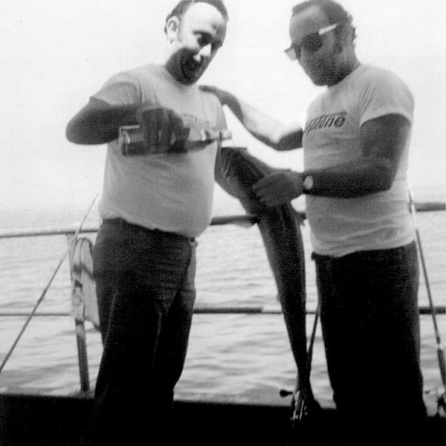
George Bell and a fellow mover, Frank Murzi, in an undated photograph.
Mr. Higginbotham quit the moving business, and moved upstate in 1973 to work for the state as an environmental scientist.
He is now 74, retired and living alone in Virginia. The last time he spoke to George Bell was 10 years ago. He used a code of ringing and hanging up to get him to answer his phone, but in time, he got no answer. He sent cards, beseeched him to come and visit, but he wouldn’t. It was two months before Mr. Higginbotham found out George Bell had died.
It has been hard for him to reconcile the way George Bell’s money came to him. “I’ve been stressed about this,” he said. “I haven’t been sleeping. My stomach hurts. My blood pressure is up. I argued with him time and again to get out of that apartment and spend his money and enjoy life. I sent him so many brochures on places to go. I thought I understood George. Now I realize I didn’t understand him at all.”
Mr. Higginbotham was content with the fundaments of his own life: his modest one-bedroom apartment, his 15-year-old truck. He put the inheritance into mutual funds and figures it will help his three grandchildren through college. George Bell’s money educating the future.
In 1994, Mr. Westbrook hurt his knee and left the moving business. He moved to Sprakers, where he had a cattle farm. When he got older and his marriage dissolved, he sold the farm but still lives nearby. He is 74. It was several years ago that he last spoke to George Bell on the phone. Mr. Bell told him he did not get out much.
He has three grandchildren and wants to move to a mellower climate. He plans to give some of the money to Mr. Murzi’s widow, because Mr. Murzi had been his best friend.
“My sister needs some dental work,” he said. “I need some dental work. I need hearing aids. The golden age ain’t so cheap. Big George’s money will make my old age easier.”
He felt awful about his dying alone, nobody knowing. “Yeah, that’ll happen to me,” he said. “I’m a loner, too. There’s maybe four or five people up here I talk to.”
In his final years, with the moving men gone, George Bell’s life had become emptier. Neighbors nodded to him on the street and he smiled. He told lively stories to the young woman next door, who lived with her parents, when he bumped into her. She recently became a police officer, and she was the one who had smelled what she knew was death.
But in the end, George Bell seemed to keep just one true friend.
He had been a fixture at a neighborhood pub called Budds Bar. He showed up in his cutoff blue sweatshirt so often that some regulars called him Sweatshirt Bell. At one point, he eased up on his drinking, then, worried about his health, quit. But he still went to Budds, ordering club soda.
In April 2005, Budds closed. Many regulars gravitated to another bar, Legends. George Bell went a few times, then transferred his allegiance to Bantry Bay Publick House in Long Island City. He would meet his friend there.
Frank Bertone, 67, is a retired inspector for Consolidated Edison. During his last decade he spent more time with George Bell than anyone, but didn’t feel he truly knew him. “One thing about George is he didn’t get personal,” he said. “Not ever.” Credit Josh Haner/The New York Times
THE SIGN at the entrance to Bantry Bay says, “Enter as Strangers, Leave as Friends.” Squished in near the window was Frank Bertone, sipping soup and nursing a drink. He is known as the Dude. George Bell’s last good friend.
In the early 1980s, not long after moving to Jackson Heights, he stopped in at Budds in need of a restroom. A big man had bellowed, “Have a beer.”
That was George Bell. In time, a friendship was spawned, deepening during the 15 years that remained of George Bell’s life. They met on Saturdays at Bantry Bay. They fished in the Rockaways and at Jones Beach, sometimes with others. Mr. Bell bought a car to get out to the good spots, but the car otherwise mostly sat. They passed time meandering around, the days bleeding into one another.
“Where did we go?” Mr. Bertone said. “No place. One time we sat for hours in the parking lot of Bed Bath & Beyond. What did we talk about? The world’s problems. Just like that, the two of us solved the world’s problems.”
Mr. Bertone is 67, a retired inspector for Consolidated Edison. Over the last decade, he had spent more time with George Bell than anyone, but he didn’t feel he truly knew him.
“One thing about George is he didn’t get personal,” he said. “Not ever.”
He knew he had never married. He spoke of girlfriends, but Mr. Bertone never met any. The two had even swapped views on wills and what happens to your money in the end, though Mr. Bertone did not know George Bell had drafted a will before they met.
Mr. Bertone would invite him to his place, but he would beg off. George Bell never had him over.
Once, some eight years ago, Mr. Bertone trooped out there when he hadn’t heard from him in a while. George Bell cracked open the door, shooed him away. A curtain draped inside the entryway had camouflaged the chaos. Mr. Bertone had no idea that at some point, George Bell had begun keeping everything.
The Dude, Mr. Bertone, told a story. A few years ago, George Bell was going into the hospital for his heart and had asked him to hold onto some money. Gave him a fat envelope. Inside was $55,000.
Mike Kerins, a bartender, interrupted: “Two things about George. He gave me $100 every Christmas, and he never went out to eat.” He had confessed he was too embarrassed because he would have required three entrees.
Photo
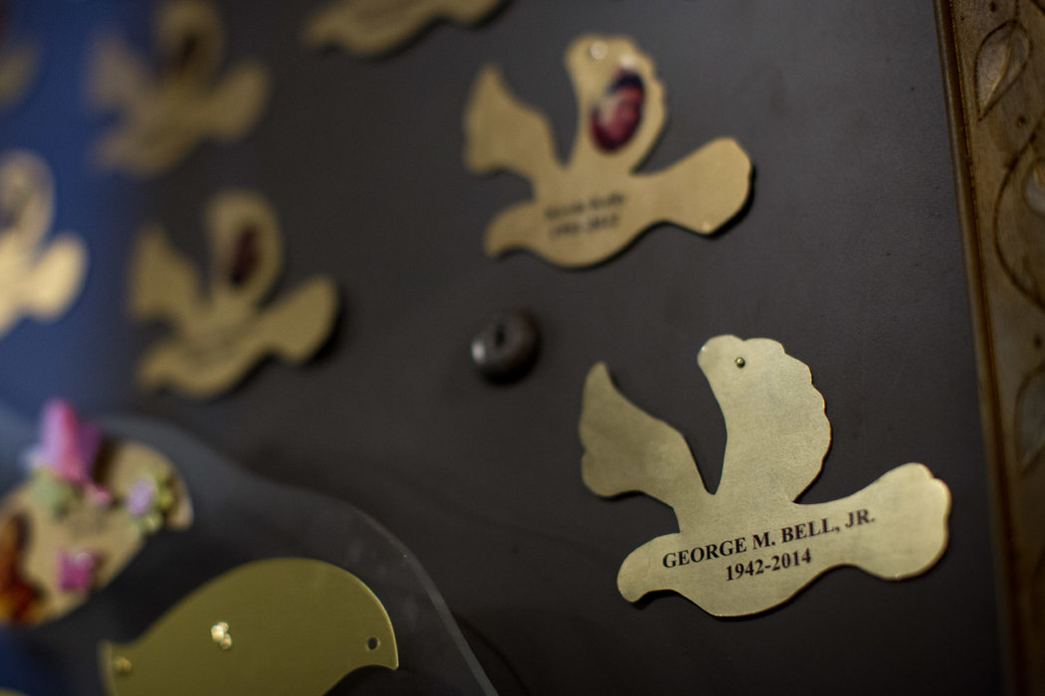
Several days after George Bell's cremation, the superintendent stacked an urn inside the storage area, then nailed a metal dove, wings spread, above the door, identifying the new addition. Credit Josh Haner/The New York Times
George Bell had diabetes and complained about a shoulder pain. He took pills but skipped them during the day, saying they made him feel like an idiot.
Both the Dude and Mr. Kerins sensed he felt he had been bullied too hard by life. “George was in a lot of pain,” Mr. Kerins said. “I think he was just waiting to die, had lived enough.”
It was as if sadness had killed George Bell.
His days had become predictable, an endless loop. He stayed cloistered inside. Neighbors heard the regular parade of deliverymen who brought him his takeout meals.
The last time the Dude saw George Bell was about a week before his body was found. Frozen shrimp was on sale at the shopping center. George Bell got some, to take back to the kitchen he did not use.
Mr. Bertone didn’t realize he had died until someone came to Legends with the news. Mr. Kerins was there and he told the Dude. They made some calls to find out more, but got nowhere.
Why did he die alone, no one knowing?
The Dude thought on that. “I don’t know, man,” he said. “I wish I could tell you. But I don’t know.”
On the televisions above the busy bar, a woman was promoting a cleaning product. In the dim light, Mr. Bertone emptied his drink. “You know, I miss him,” he said. “I would have liked to see George one more time. He was my friend. One more time.”
Correction: October 17, 2015
Because of an editing error, an earlier version of a picture caption with this article referred incorrectly to the transporting of George Bell’s body. It is shown being taken to a crematorium, not to a morgue.
N.R. Kleinfield has written for The New York Times for nearly 40 years. Read his article last year about a New York City firefighter’s first fire and other work by him.

