Certified Peer Specialist Training Application | 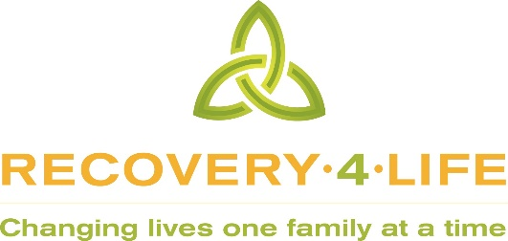

Contact Information
Name
Street Address
City ST ZIP Code
Cell Phone
Work Phone
E-Mail Address

Recovery Experience

Summarize your life experience in mental health recovery, including behavioral health systems you have navigated, personal growth, spiritual growth, hobbies, social, or sports activities.

List two persons familiar with your mental health recovery

Name, Occupation, Phone Number

Person to Notify in Case of Emergency
Name
Street Address
City ST ZIP Code
Cell Phone
Work Phone
E-Mail Address

Agreement and Signature

By submitting this application, I affirm that the facts set forth in it are true and complete. I understand that if I am accepted as a volunteer, any false statements, omissions, or other misrepresentations made by me on this application may result in my immediate dismissal.
Name (printed)
Signature
Date

Our Policy

It is the policy of this organization to provide equal opportunities without regard to race, color, religion, national origin, gender, sexual preference, age, or disability.

Thank you for completing this application form and for your interest in attending the Certified Peer Specialist Training. Once your application is submitted you will be contacted in regards to submitting references and registration.

