September at the Latah Recovery Center
Alcoholics Anonymous Every day, noon
Positive Affirmations Mondays and Weds 1:10-2
YOU Can Create Your Own Job Monday 9/19, 6
Life Skills Tuesdays 5-6
Intro to WRAP pt.2 Wednesday 9/14, 1:15
Mindful Meditation and Yoga Thursdays 2-3
Journal Writing Thursday 9/1, 8, 15, 22 4-5
How to Explain Things in Writing Thursday 9/1, 15, 22 6:30-7:30
LAMI: Family Support Program 2nd Thurs of month 7-8:30
Narcotics Anonymous Fridays 7:30-8:30am
All Recovery Meeting Fridays 5-6, starts 9/9
Movie and Game Night Fridays 6:30-9
Learn to Crochet & Rewire your Brain Saturday 9/24 10-Noon
Latah Recovery Festival-East City Park Saturday 10/1 5-10
Presence: How to Transform Your Most
Challenging Emotions w/Ann Weiser Cornell Sunday 9/11 1-4
Adult Children of Alcoholics, Women’s Meeting Sundays 6-7:30
Classes and Groups are ALWAYS FREE. Please RSVP.
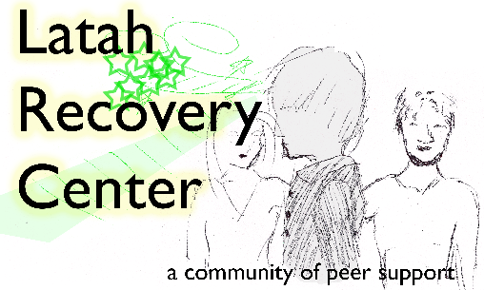
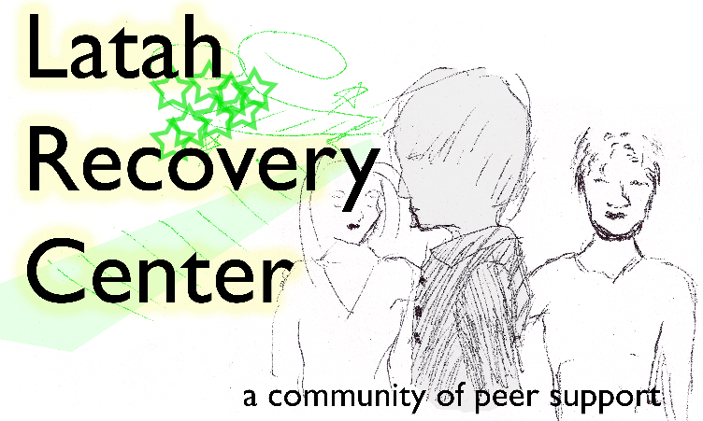
Upcoming:

