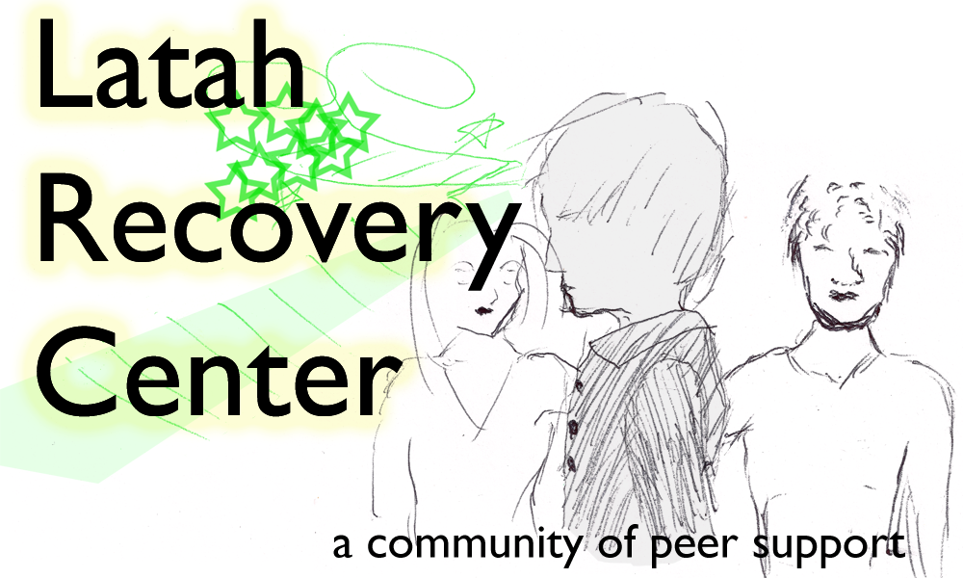

Trauma Informed Care:

* What is Trauma
* Learning to not Re-Traumatize
* Trauma Effects
* Trauma Informed Systems
* Trauma Informed Responses

Date:

September 28, 2015

Time:

3:00pm to 7:00pm

Location:

Latah Recovery Center



Latah Recovery Center

531 S. Main St. #B

Moscow, Id 83843

Phone:

208-883-1409

E-mail: latahrecoverycenter@gmail.com

## Latah Recovery Center Presents a SAMHSA Training

# Trauma Informed Care Training