Ecology of
Aspen, Beaver Ponds, and Trout 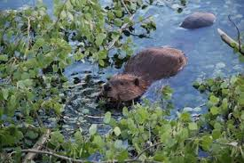
in the Rocky Mountains
Presented by Professor Emeritus Fred Rabe
Thursday, September 26, 7:00pm
1912 Center, Great Room
412 E. Third St., Moscow, Idaho
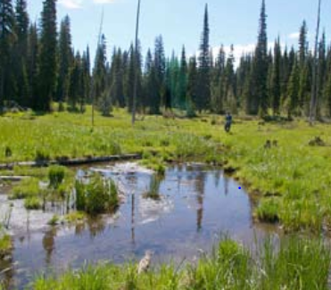
Abandoned beaver pond, in the proposed Research Natural Area
“49 Meadows,” St. Joe National Forest
Sponsored by the Idaho Native Plant Society, White Pine Chapter
http://www.whitepineinps.org

