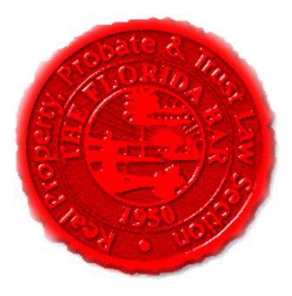 |  | Insurance & Surety Committee  Florida Bar - RPPTL Section  Executive Council Meeting  Thursday, March 31, 2022 1:00 - 2:00 PM  In Person - Room 205 or Remote Via Zoom  Join Zoom Meeting  https://us06web.zoom.us/j/85973632473?pwd=cHdPcDdjRVhRT1U1Z2liZEVmV2RyQT09  Meeting ID: 859 7363 2473  Passcode: 416615  One tap mobile  +13017158592,,85973632473# US (Washington DC)
Meeting called by: |  |  | Michael Meyer, Katie Heckert, and Debbie Crockett
Type of meeting: |  |  | Insurance and Surety Committee - Executive Council Meeting
 | Agenda topics
 | Introduction |  |  | Katie Heckert
 | Brainstorm Session re Insurance and Surety Committee |  |  | Michael Meyer / Katie Heckert
 | Board Certification |  |  | Debbie Crockett
 | Adjourn

