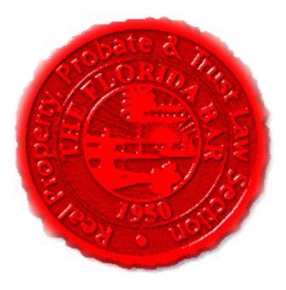  Agenda |  |  | Insurance & Surety Committee, RPPTL Section, Florida Bar  Monthly Telephone Conference  September 20, 2021, at 12 Noon  60 Minutes  Zoom Link in Agenda Email
Meeting called by: |  | Michael Meyer/Katie Heckert/Mariela Malfeld
Type of meeting: |  | Insurance and Surety Committee - Monthly Telephone Conference
 | Agenda topics
 | Introduction |  |  | Michael Meyer
 | Upcoming Executive Council Meeting at Luminary Hotel,  November 3-7, 2021 – More details on meeting format (i.e., Live or Zoom) and speaker/presentation to come in following months |  |  | Michael Meyer/Katie Heckert
 | Upcoming CLE’s 2021-2022 |  |  | Katie Heckert /Michael Meyer
 | CLE Presentation - “Captive Insurance Programs” |  |  | Hale Stewart, JD, LLM, The Law Office of Hale Stewart, Houston, TX
 | Adjourn

