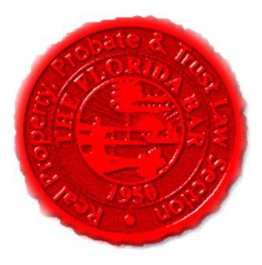  Agenda |  | Insurance & Surety and Construction Law Committees  Florida Bar - RPPTL Section  Executive Council Meeting  Monday, July 19, 2021  12:00 – 1:15 PM  https://zoom.us/j/94374016002?pwd=RzRWTU9zRWY3NHRycDZKQTZ2R0JPQT09
Meeting called by: |  | Michael Meyer/Reese Henderson
Type of meeting: |  | Joint Insurance & Surety and Construction Law Committees Virtual Meeting
 | Agenda Topics:
 | Introduction |  | Michael Meyer/ Reese Henderson
 | CLE: “Shifting Focus: 2021 Changes to Florida’s Fee Shifting Statute.” |  | Greg Podolak, Saxe Doernberger & Vita, P.C.
 | Insurance & Surety Committee Update |  | Michael Meyer
 | Construction Law Committee Update |  | Reese Henderson
 | Adjourn

