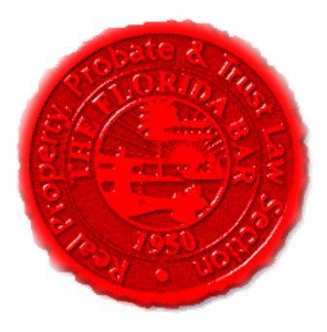  Agenda |  |  | Insurance & Surety Committee, RPPTL Section, Florida Bar  Monthly Telephone Conference  October 19, 2020, at 12 Noon  60 Minutes  Zoom Link in Agenda Email
Meeting called by: |  | Michael Meyer/Mariela Malfeld/Katie Heckert
Type of meeting: |  | Insurance and Surety Committee - Monthly Telephone Conference
 | Agenda topics
 | Introduction |  |  | Michael Meyer
 | Insurance Matters! Newsletter Update  Executive Council Meeting at Disney’s Yacht Club,  December 3-5, 2020 – NOTE: Live and Zoom attendance  will be facilitated for most committee meetings (including a  joint meeting between ISC and CLC |  |  | Mariela Malfeld/Michael Meyer  Michael Meyer
 | Upcoming CLE’s 2020 |  |  | Katie Heckert /Michael Meyer
 | CLE Presentation - “Insurance and Coverage Considerations for COVID-19 Claims” |  |  | Chip Storm, AFIS, Director of Corporate Risk & Broking, and Henry Daar, the National Property Claims Director, with Willis Towers Watson
 | Adjourn

