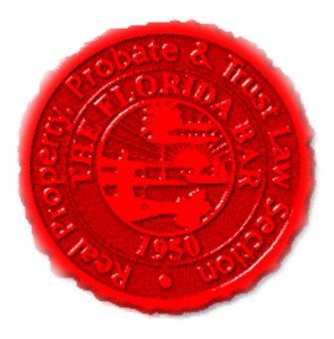  Agenda |  |  | Insurance & Surety Committee, RPPTL Section, Florida Bar  Monthly Telephone Conference  July 20, 2020, at 12 Noon  60 Minutes  Dial-in: 888-376-5050  Passcode: 7854216320#  Moderator Code: 36802#. To start/end recording of meeting, press #7. To mute and unmute lines press *7
Meeting called by: |  | Michael Meyer/Mariela Malfeld/Katie Heckert
Type of meeting: |  | Insurance and Surety Committee - Monthly Telephone Conference
 | Agenda topics
 | Introduction  June’s Minutes |  |  | Michael Meyer  Michael Meyer
 | Insurance Matters! Newsletter Update  Executive Council Meeting and Legislative and  Case Law Update at the Breakers, August 20-22, 2020 |  |  | Mariela Malfeld/Michael Meyer  Michael Meyer
 | Upcoming CLE’s 2020 |  |  | Katie Heckert /Michael Meyer
 | CLE Presentation - “Mitigating COVID-19 Construction Risks – Common Law Excuse of Performance Doctrines, Claims Considerations, and Builder’s Risk Insurance” |  |  | Brett M. Henson, Esq., an attorney with Shumaker in their Sarasota, FL office; and Brian D. Solomon, Esq., an attorney with Kirwin Norris, P.A. in their Melbourne, FL office.
 | Adjourn

