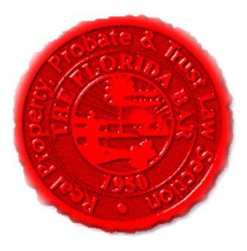  Agenda |  |  | Insurance & Surety Committee, RPPTL Section, Florida Bar  Monthly Telephone Conference  May 18, 2020  60 Minutes  Dial-in: 888-376-5050  Passcode: 7854216320#  Moderator Code: 36802#. To start/end recording of meeting, press #7. To mute and unmute lines press *7
Meeting called by: |  | Michael Meyer/Mariela Malfeld/Katie Heckert
Type of meeting: |  | Insurance and Surety Committee - Monthly Telephone Conference
 | Agenda topics
 | Introduction  January’s Minutes |  |  | Michael Meyer  Michael Meyer
 | Insurance Matters! Newsletter Update |  |  | Mariela Malfeld/Michael Meyer
 | Upcoming CLE’s 2020 |  |  | Katie Heckert /Michael Meyer
 | CLE Presentation - “Construction Insurance 101: Builders Risk” |  |  | Eric M. Gold, Esq. and Stephen S. Asay, Esq., attorneys with Pillsbury Winthrop Shaw Pittman LLP, Washington D.C.
 | Adjourn

