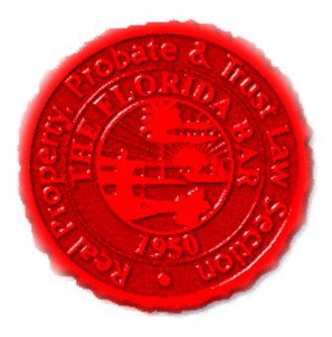  Agenda |  | Construction Law and Insurance & Surety Committees  Florida Bar - RPPTL Section  Annual Convention Meeting  Thursday, May 30, 2019  9:30 – 11:00 AM  90 Minutes  Dial-in: TBD  Passcode: TBD
Meeting called by: |  | Reese Henderson/Michael Meyer/Scott Pence
Type of meeting: |  | Construction Law and Insurance & Surety Committees – Annual Convention Live Meeting
 | Agenda Topics:
 | Introduction |  | Reese Henderson/Michael Meyer
 | Insurance Matters! Newsletter Update |  | Mariela Malfeld/Michael Meyer
 | Upcoming CLE’s (2019) |  | Michael Meyer/Reese Henderson
 | Insurance Legislation Update  Construction Legislation Update |  | Michael Meyer  Reese Henderson
 | Adjourn

