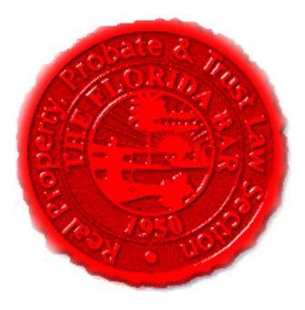  Agenda |  | Insurance & Surety Committee  Florida Bar - RPPTL Section  Monthly Telephone Conference  March 18, 2019  60 Minutes  Dial-in: 888-376-5050  Passcode: 7854216320#  Moderator Code: 36802#. To start and end recording of meeting, press #7. To mute and unmute lines, press *7]
Meeting called by: |  |  | Scott Pence/Michael Meyer/Mariela Malfeld/Katie Heckert/Fred Dudley
Type of meeting: |  |  | Insurance and Surety Committee - Monthly Telephone Conference
 | Agenda topics
 | Introduction  Approve February’s Minutes |  |  | Scott Pence/Michael Meyer  Scott Pence/Michael Meyer
 | Insurance Matters! Newsletter |  |  | Mariela Malfeld /  Cynthia Beissel
 | Upcoming CLE’s (2019) |  |  | Michael Meyer
 | Recent Executive Council Meeting – March 13 – 17, 2019,  Omni Plantation Resort, Amelia Island, FL |  |  | Michael Meyer
 | CLE Presentation – “Difference Between Warranty, Service Contract & Insurance, and Subrogation/Loss Recovery” |  |  | Aaron E. Lunt, JD, CPCU, ARe – AVP, Assistant General Counsel – Legal Services CNA
 | Adjourn

