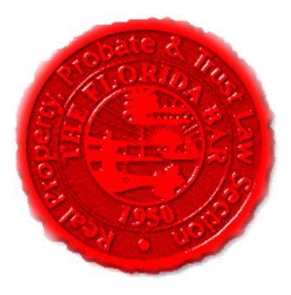 |  | Insurance & Surety Committee  Florida Bar - RPPTL Section  Monthly Telephone Conference  October 15, 2018  60 Minutes  Dial-in: 888-376-5050  Passcode: 7854216320#  Moderator Code: 36802#. To start and end recording of meeting, press #7. To mute and unmute lines, press *7]
Meeting called by: |  |  | Scott Pence/Michael Meyer/Mariela Malfeld/Katie Heckert/Fred Dudley
Type of meeting: |  |  | Insurance and Surety Committee - Monthly Telephone Conference
 | Agenda topics
 | Introduction |  |  | Scott Pence
 | Insurance Matters! Newsletter |  |  | Mariela Malfeld /  Cynthia Beissel
 | Upcoming CLE (2018-2019) |  |  | Michael Meyer
 | CLE Presentation – Workers’ Compensation and Related Issues |  |  | William “bill” Zachry  of The Sedgwick Institute
 | Adjourn

