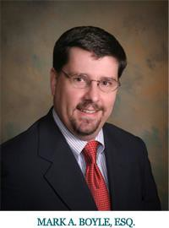

About Mark A. Boyle

Mark A. Boyle is the managing shareholder of Boyle & Leonard, P.A., with offices in Fort Myers, FL, Tampa, FL, and Charleston SC. He began his legal career working as an Assistant County Attorney for Pasco County in New Port Richey, Florida. Mr. Boyle began his foray into the world of insurance when he became associate general counsel for Armor Insurance Company in Tampa, Florida. In 1996, he entered into private practice with Fink & Lane, P.A., which is now known as Boyle & Leonard, P.A.

Mr. Boyle’s current areas of practice include civil litigation, with a concentration in first and third party insurance disputes, including extra-contractual and bad faith matters. Mr. Boyle represents corporate and individual policyholders in insurance and risk management counseling, claims presentation, and litigation. Mr. Boyle was the principal attorney in U.S. Fire Ins. Co. v. J.S.U.B., Inc., 979 So. 2d 871 (Fla.2007), at trial and through all phases of appeal. J.S.U.B. is the seminal decision in Florida as to what constitutes a covered “occurrence” and “property damage” under commercial general liability policies in a construction defect setting. Recently, with the assistance of co-counsel, the firm prevailed in the matter of Sebo v. American Home Assurance Co., 208 So. 3d 694 (Fla. 2016). The Sebo decision reaffirmed Florida’s fealty to the Concurrent Cause Doctrine in first party insurance disputes and disallowed the insurers attempt to apply the highly restrictive Efficient Proximate Cause Doctrine.

Mr. Boyle is a 1993 graduate from Stetson College of Law, located in St. Petersburg, Florida. In 1990, Mr. Boyle received a Bachelor of Arts in History and a Bachelor of Science in Natural Sciences from the University of South Florida.

