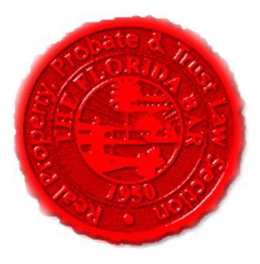 |  | Insurance & Surety Committee  Florida Bar - RPPTL Section  Monthly Telephone Conference  November 20, 2017  60 Minutes  Dial-in: 888-376-5050  Passcode: 7854216320#  Moderator Code: 36802#. To start and end recording of meeting, press #7. To mute and unmute lines, press *7]
Meeting called by: |  |  | Scott Pence/Michael Meyer/Fred Dudley
Type of meeting: |  |  | Insurance and Surety Committee - Monthly Telephone Conference
 | Agenda topics
 | Introduction |  |  | Scott Pence
 | Approval of Minutes |  |  | Scott Pence
 | Insurance Matters! Newsletter |  |  | Scott Pence
 | Upcoming CLE  “Insurance 101” Series |  |  | Michael Meyer
 | Special In-Person Meeting at EC Meeting  8 AM - 9 AM, December 8, 2017, Ritz Carlton, Naples, FL  CLE Presentation TBD |  |  | Scott Pence
 | CLE Presentation – Case Law Update |  |  | Michael Meyer, Esq.
 | New Business |  |  | All

