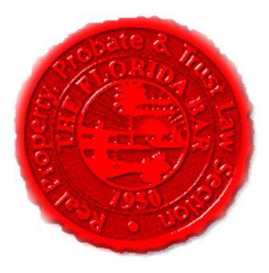 | Insurance & Surety Committee  Special In-Person Meeting  Hyatt Regency Coconut Point, Bonita Springs, FL  June 2, 2017  1:30 PM -2:30 PM  Great Egret Conference Room  If unable to attend in person:  Dial-in: 888-376-5050  Passcode: 7854216320#  Moderator Code: 36802#. To start and end recording of meeting, press #7. To mute and unmute lines, press *7]
Meeting called by: | Cary Wright/Scott Pence/Michael Meyer/Fred Dudley
Type of meeting: | Insurance and Surety Committee
 | In-Person Meeting – Coinciding with Executive Council Meeting
 | Agenda topics
 | Introduction | Cary Wright
 | Flood Insurance Bill | Trey Goldman
 | Board Certification | Scott Pence
 | Insurance Matters | Scott Pence
 | Website | Michael Meyer/Derrick Valkenburg
 | Upcoming CLE | Michael Meyer
 | Annual Convention | Cary Wright
 | CLE Presentation – Update on 2017 Legislative Session | Frederick (“Fred”) R. Dudley, Esq., of Dudley, Sellers Heath & Healy, P.L. in Tallahassee
 | New Business | All

