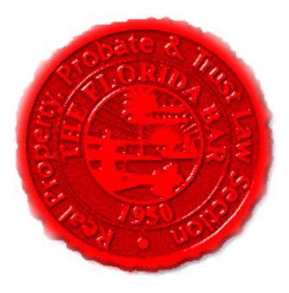 | Insurance & Surety Committee  Special In-Person Meeting  The Breakers, Palm Beach, FL  July 28, 2016  8:00 AM -9:00 AM  Dial-in: 888-376-5050  Passcode: 7854216320#  Moderator Code: 36802#. To start and end recording of meeting, press #7. To mute and unmute lines, press *7]
Meeting called by: | Cary Wright/Scott Pence
Type of meeting: | Insurance and Surety Committee - Monthly Telephone Conference
 | Agenda topics
 | Introduction | Cary Wright
 | Insurance Matters | Scott Pence
 | Upcoming CLE | Michael Meyer
 | Website | Michael Meyer
 | Upcoming CLE Series on Risk Management | Michael Meyer/Scott Pence
 | Articles for Newsletter and ActionLine | All
 | Section CLE/Webinar Ideas | All
 | New Business | All

