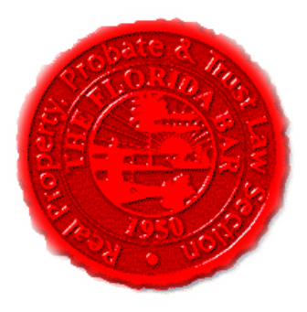  Agenda |  | Insurance & Surety and Construction Law Committees  Florida Bar - RPPTL Section  Executive Council Meeting  Friday, April 23, 2021  3:00 – 4:30 PM  PRE-REGISTRATION REQUIRED  (Use This Link to Pre-Register)  https://zoom.us/meeting/register/tJYoduGrpzMqEtHiHGIsFfYb14e3Jmz34_Tc
Meeting called by: |  | Michael Meyer/Reese Henderson
Type of meeting: |  | Joint Insurance & Surety and Construction Law Committees Zoom Meeting
 | Agenda Topics:
 | Introduction |  | Michael Meyer/ Reese Henderson
 | CLE: “Property Insurance Issues in Lease Agreements” |  | Charles E. Comiskey  CPCU, CIC, CPIA, CRM, PWCA, CRIS, CCM, CMIP  Shareholder/Sr. Vice President of Brady Chapman Holland & Assoc  President of RiskTech, Inc.
 | Insurance & Surety Committee Update |  | Michael Meyer
 | Construction Law Committee Update |  | Reese Henderson
 | Adjourn

