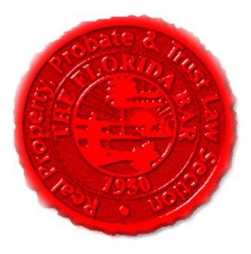  Agenda | Florida Bar - RPPTL Section Construction Law Committee / Insurance & Surety Committee Joint EC Meeting  Friday, January 31, 2020  1:30 PM -3:30 PM  Dial-in: 888-376-5050  Participant Code: 3532412014#  [Moderator Code: 65415. To start and end recording of meeting, press #7. To mute and unmute lines, press *7]
Meeting called by: | Michael Meyer/Reese Henderson
Type of meeting: | RPPTL Construction Law Committee / Insurance & Surety Committee Joint Telephone Conference (Miami EC Meeting)
Introductions |  | Reese Henderson – Chair of CLC  Michael Meyer – Chair of ISC
Reports
Upcoming Insurance & Surety Committee CLEs |  | Katie Heckert/Michael Meyer
CLC Legislative Subcommittee –  HB 283 – Lien Law revision  HB 897 – Competing Lien Law bill  HB 295 – Construction Defects Bill |  | Sean Mickley/Reese Henderson
CLC CLE Presentation: “Construction Plan Review for Lawyers” |  | Brice Miller

