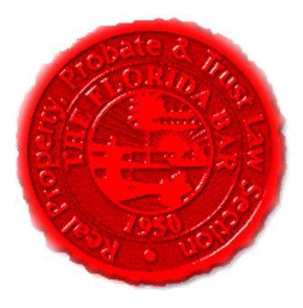  Agenda | Florida Bar - RPPTL Section Construction Law Committee / Insurance & Surety Committee Joint EC Meeting  Friday, November 8, 2019  3:30 PM -5:00 PM  Dial-in: 888-376-5050  Participant Code: 3532412014#  [Moderator Code: 12141. To start and end recording of meeting, press #7. To mute and unmute lines, press *7]
Meeting called by: | Michael Meyer/Reese Henderson
Type of meeting: | RPPTL Construction Law Committee / Insurance & Surety Committee Joint Telephone Conference (Miami EC Meeting)
Introductions |  | Reese Henderson – Chair of CLC  Michael Meyer – Chair of ISC
Reports
Insurance & Surety Law Committee  HB 359 regarding Section 624.155  Potential Legislation revising the attorneys’ fees provision for first-party property claims under Section 627.428 |  | Michael Meyer
CLC Legislative Subcommittee –  Draft Lien Law Bill  HB 295 – Construction Defects Bill |  | Sean Mickley

