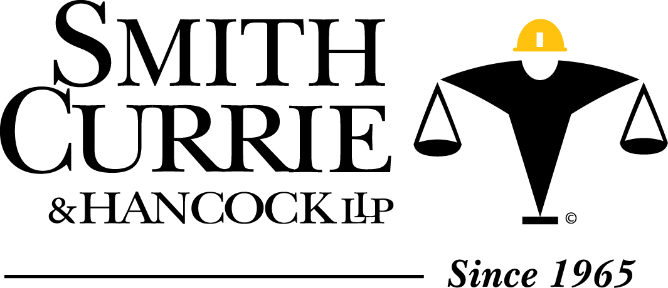

RPPTL- Construction Law Committee
Small Business Subcommittee
Lisa Colon Heron, Esq.

October 2013 Report.

I. Department of Transportation seeks additional comments on the Disadvantaged Business Enterprise: Program Implementation Modifications.

On September 6, 2012, the Department of Transportation (DOT) issued a notice of proposed rulemaking (NPRM) regarding various modifications to the DBE program. The comment period ended on December 24, 2012. Commenters requested a public meeting prior to DOT issuing a final rule. A listening session was scheduled for October 9, 2013; however it was postponed due to the government shut down. The DOT also reopened the comment period from September 18, 2013 through October 30, 2013.

The proposed changes in the NPRM include:

(a) Revisions to personal net worth, application and reporting forms.

(b) Changes to Goals, “Good Faith Efforts” and Bid submission Requirements. The DOT proposes that all relevant DBE information be provided as a matter of responsiveness at the time of bid submission. The DOT proposes to change the rules governing how a State sets its annual goals for DBE participation. The DOT proposes to revise the types of actions that qualify as “Good Faith Efforts” by a prime contractor in order to be awarded the contract if it has failed to meet the contract goal requirement.

(c) Changes to Counting Trucking Operations. DOT proposes changes to the requirements for how much of a DBE trucking company’s involvement can be counted towards goal achievement.

(d) Changes to Rules Governing Determination of Ownership. The DOT changes clarify that contribution of capital and expertise for startup must be provided by the DBE owner of at least 51%.

(e) Clarification of Rules Governing Determination of Control. The proposed change clarifies that that a non disadvantaged person may not possess or exercise power to control the firm.

(f) Expands type of information collected on DBE.

II. United States v. Blanchet – 518 Fed. Appx. 932 (Fla. C.A. 11 , May 21, 2013)

Case involves the Defendants’ convictions that arise out of their company’s procurement of the $100 million, small business set-aside contract with the federal government in 2007. The contract was for the provision of foreign language instruction services to the United States Special Operations Command (SOCOM). The convictions stem from the Defendants misrepresenting and concealing facts about their company’s affiliation with another, larger company, both in the initial bid and during the government’s later investigation. The facts of this case is a good reminder of what your clients cannot do when attempting to set up a small business to pursue 8a set aside work.

